ANNEXURE TO STRIKE NOTICE

This National Convention of Workers, organised jointly by the Central Trade Unions and independent National Federations/Associations, being held on 2nd October 2020, strongly condemns the onslaught on the basic democratic and constitutional rights of the Workers, Farmers and Common People of our country by Modi led BJP government at the Centre as well as by BJP ruled State Governments.

The BJP Government have got the three Labour Codes passed in Parliament most undemocratically, when the opposition parties were absent in the House. These Labour Codes are designed to impose virtual slavery on the workers, making formation of trade unions very difficult and imposed cruel restrictions on right to trade union and right to strike.

Without even placing the Electricity (Amendment) Bill,2020 in Parliament, the Government has started privatising electricity distribution network ignoring opposing views by 12 Chief Ministers’, leaving the existing Employees at the mercy of the new franchise owners. Earlier, they resorted to merger of public sector banks without any effort at recovering huge NPA accounts, endangering common people’s money in banks. RBI, LIC and various PSEs are being used as ATMs.

Further suicidal privatisation of PSUs through auctions and 100% FDI: be it railway routes, railway stations, railway production units, airports, Port & Docks, profit making Government Departments, Coal Mines, cash rich PSEs like BPCL, 41 Ordnance Factories, BSNL (calling their 86,000 employees Deshdrohis), Air India, Road Transports, Energy Sector PSUs are being aggressively pushed.

This convention notes that various sections of workers and toiling people are tenaciously fighting the anti-people policies of the Government. The coal workers’ three days’ strike, the BPCL workers two day strike, demonstrations and struggles of RTC workers, oil workers, steel workers, port workers, cement workers, scheme workers and workers and employees of various other sectors, victorious struggles of the electricity workers and engineers in UP. ONGC, the Maharatna oil PSU has been forced to become a debt laden company. BPCL has been put for sale only @ Rs.60,000.00 Crores against the actual assets of more than Rs.9.5 Lakh Crores. Similarly, Coal, Shipyard, Steel, BSNL, BEL, BHEL, Pharmaceutical PSUs, LIC, Indian Railways etc are in total danger of privatisation. Shockingly even oil or power sector is not accepted as strategic sector by Modi Government. More than 90 oil fields, which were discovered by ONGC and OIL have been handed over to the private parties.

This convention calls upon the working class to observe one day country wide general strike on 26th November, 2020 on the following demands.

- Cash transfer of Rs 7500 per month for all non income tax paying families
- 10 kg free ration per person per month to all needy
- Expansion of MGNREGA to provide 200 days’ work in a year in rural areas at enhanced wages; extension of employment guarantee to urban areas
- Withdraw all anti farmer laws and anti worker labour codes
- Stop privatisation of public sector and stop corporatisation of Govt run manufacturing and service entities like Railways, Ordinance Factories, Ports etc.
- Withdraw the draconian circular on forced premature retirement of Government & PSU Employees
- Provide Pension to all, scrap NPS and restore earlier Pension, improve EPS-95

With continuous deepening of the crisis, the Government has become deadly desperate to privatize CPSUs indiscriminately including those in core and strategic sectors of the economy. The loot and plunder of public sector can be noted from the fact that apart from the huge collection through different modes of privatization Government is imposing more and more financial burdens on the CPSUs.

Contribution in PM Care Fund, imposition financial target for Capex apart from dividend, taxes and duties and more. More than 55 CPSUs have been rather forced to contribute to PM CARES (Prime Minister’s Citizen Assistance and Relief in Emergency Situations) According to available figure 38 CPSUs have paid more than Rs.2,105.00 crores to PM Cares. Obviously the total figure is much more. The shocking fact is that the CPSUs which have been declared ‘inefficient’ and ‘unviable’ have also been compelled to contribute. One of the examples, the Airport Authority of India.

The Convention calls upon all the working people, whether unionised or not, affiliated or independent, whether from organised sector or unorganised sector, to intensify the united struggle against the anti-people, anti-worker, anti-farmer and anti-national policies of the Govt and make the call for countrywide general strike on 26th November, 2020 a total success. Let it be known that this One Day Strike is in preparation for more intense, more tenacious and longer struggles that lie ahead. The Convention appeals to CPSU employees irrespective of affiliations to prepare and participate in the strike in do or die perspective.
(Edited extracts from the Declaration adopted at the
All India Convention of Workers on 2nd October 2020)
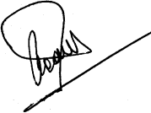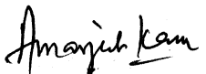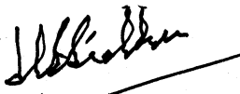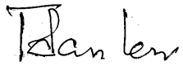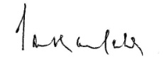
G. Sanjeeva Reddy Amarjeet Kaur H. S. Sidhu Tapan Sen Shankar Saha
INTUC AITUC HMS CITU AIUTUC
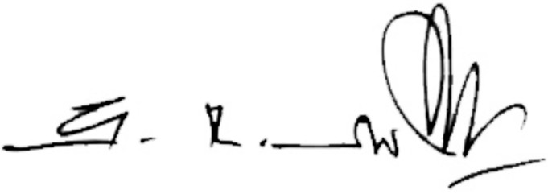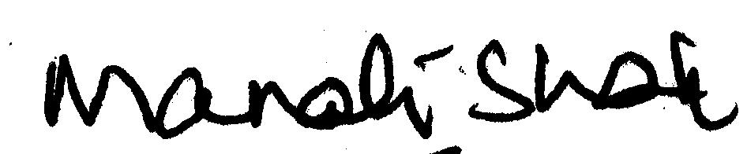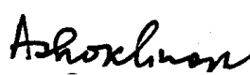
G. Devarajan Manali Shah Rajiv Dimri M. Shanmugam Ashok Ghosh
TUCC SEWA AICCTU LPF UTUC

And INDEPENDENT FEDERATIONS/ASSOCIATIONS

